# Tic-tac-toe with RP2040

## Schematic description

This construction is the simple tic-tac-toe game based on Raspberry Pi Pico (RP2040 module). The matrix of 3x3 Neopixel RGB LED chain is connected to GPIO0 pin. Play buttons are connected as 3x3 matrix with 3 columns and 3 rows.

Another 2 Neopixel LED chain is connected to GPIO1 pin. 2 buttons for player selection are connected to GPIO2 and GPIO3 pins.

Game can be powered from USB or from 4 AAA batteries. DC-DC step-down is used to achieve 5V power supply. Schottky diode is used to separate USB and battery power supply.

## Construction

Resistors shall be populated first, then Schottky diode, RP2040 module and DC-DC step-down module. Then we populate transistor, LEDS, buzzer, terminal, buttons and power switch.

## How to get it into service

It should work on the first try when everything was soldered well. Firmware shall be saved to RP2040. You can use e.g. Thonny IDE. Source code can be found in git repository.

## Bill of materials

|  |  |  |
| --- | --- | --- |
| **Annotation** | **Type** | **Qty** |
| BZ1 | Passive buzzer | 1 |
| D1,D2,D3,D4,D5,D6,D7,D8,D9,D10,D11 | APA-106-F5 | 11 |
| D12 | BAT85 | 1 |
| J1 | Screw terminal 3.5mm | 1 |
| Q1 | BC546 | 1 |
| R1 | 100k | 1 |
| R2 | 10k | 1 |
| SW1,SW2,SW3,SW4,SW5,SW6,SW7,SW8,SW9,SW10,SW11 | Turbo switch 7x7 | 11 |
| SW12 | 7x7mm button | 1 |
| U1 | WaveShare RP2040 | 1 |
| U2 | DC-DC | 1 |

## Button orientation and board assembly

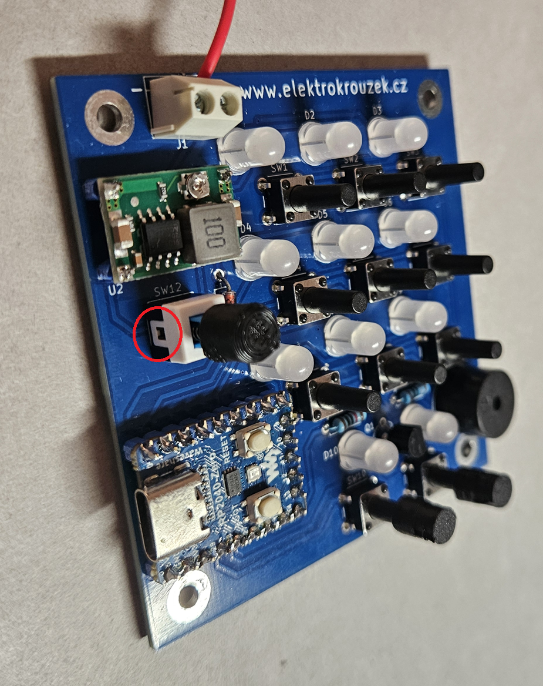

## Assembly sheet

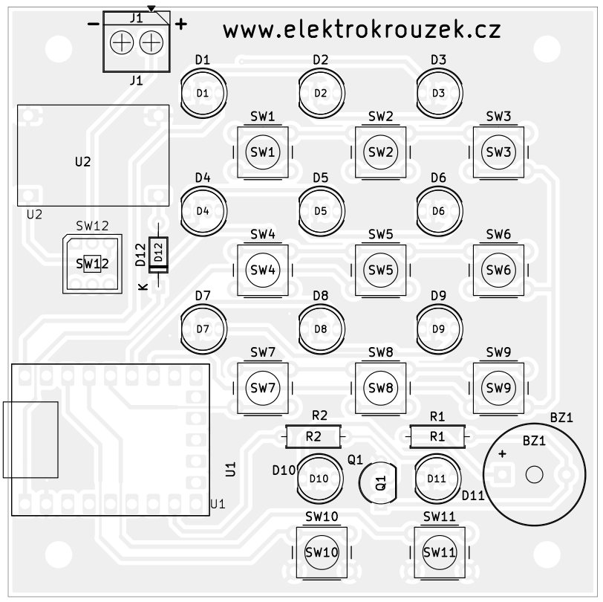

## Mechanical assembly

Button covers are placed into holes of the front cover - do not glue them! Then the button holder is placed and glued to the front cover. Also, two LED covers are glued to the front cover.

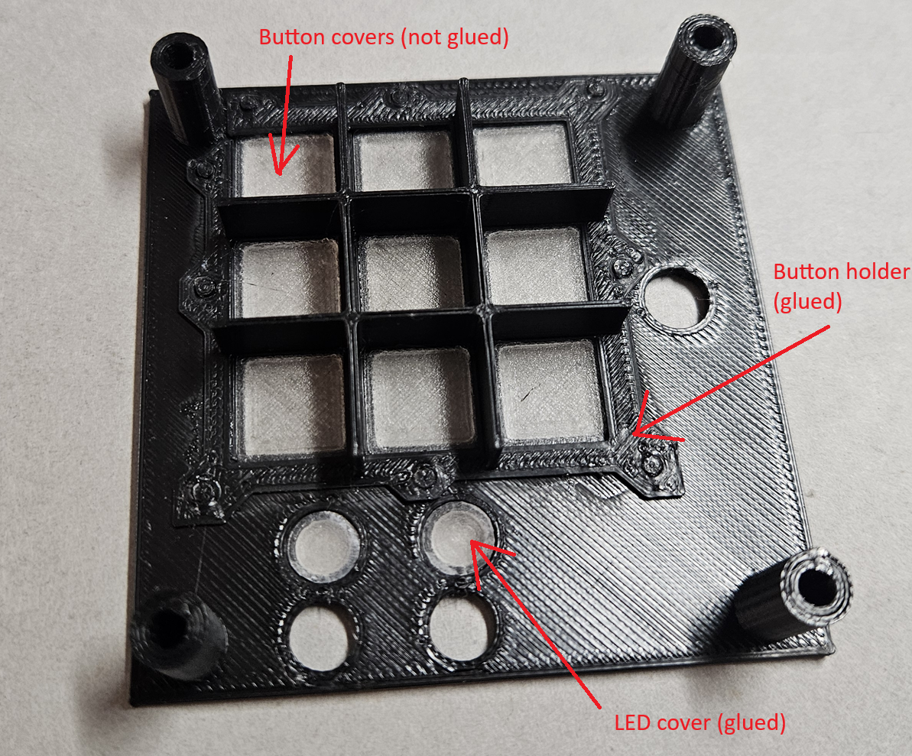

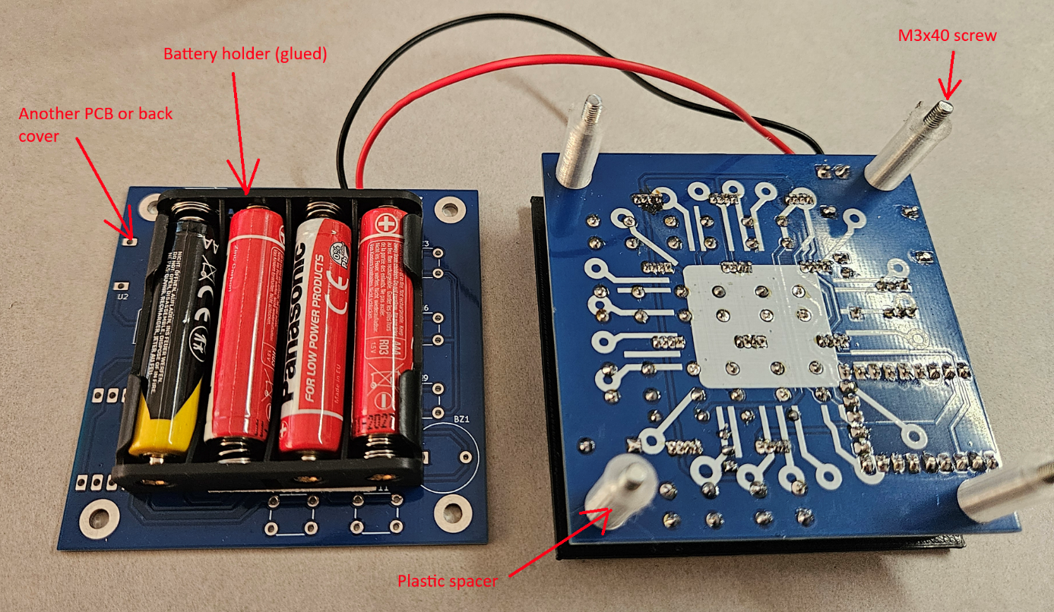

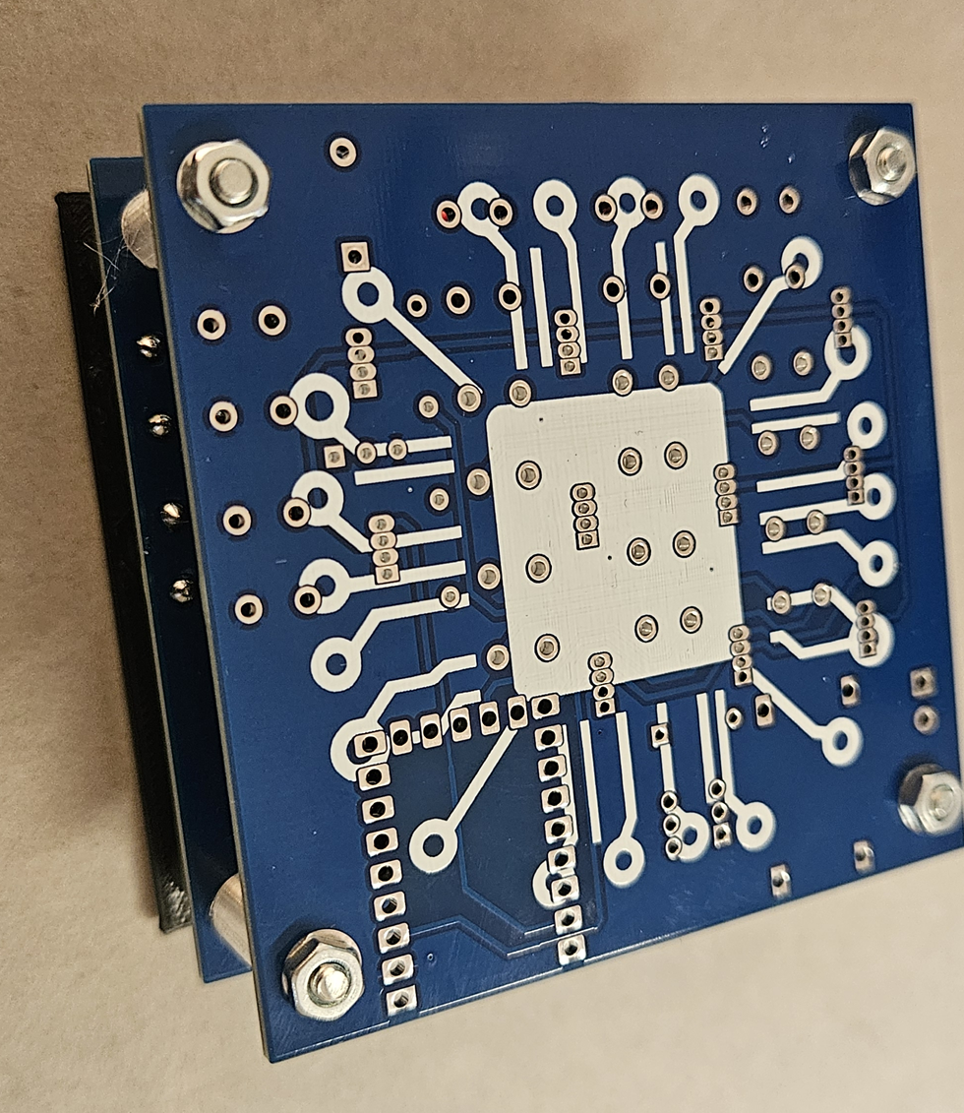

## Schematic

